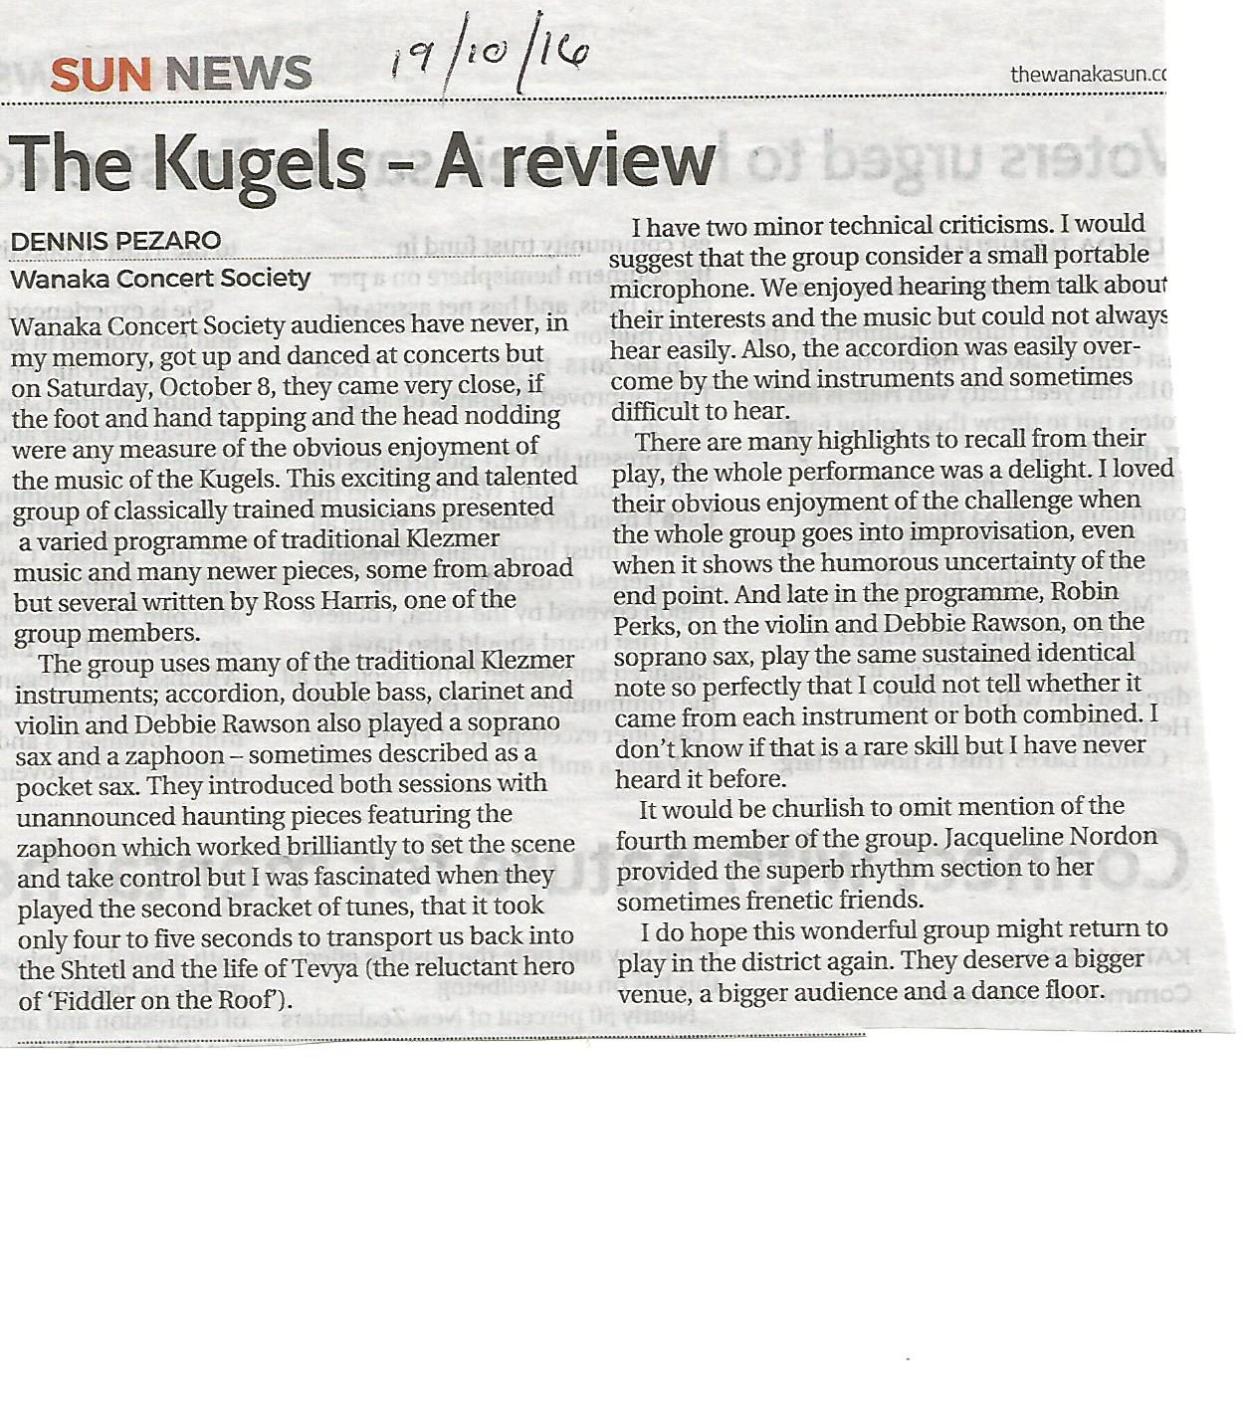

G_e_r_a_l_d_i_n_e_ _C_o_m_m_u_n_i_t_y_ _A_r_t_s_ _C_o_u_n_c_i_l_

_I_n_c_o_r_p_o_r_a_t_e_d_ _

P_R_E_S_S_ _R_E_L_E_A_S_E_ _– _1_4_t_h_ _O_c_t_o_b_e_r_,_ _2_0_1_6_ _
K_U_G_E_L_S_’ _K_L_E_Z_M_E_R_ _T_H_R_I_L_L_S_ _G_E_R_A_L_D_I_N_E_ _A_U_D_I_E_N_C_E_ _
Almost 100 people packed the Geraldine Town and Country Club on Tuesday evening to hear this amazing ensemble, bringing together their shared passion for Jewish Klezmer music and their not inconsiderable musical accomplishment, in a concert of rare quality that would grace any of the top auditoria, worldwide.
It was an evening of great intimacy where the artists took their time to explain the history of Klezmer and introduced their instruments in a way that the whole audience felt included and valued by the performers.
The atmospheric, evocative and incredibly moving material lifted the audience and took them straight to the heart of the Eastern Europe of the 19th and early 20th Centuries. A true measure of the performance was that the two hours seem to be gone in a heartbeat leaving each one of us wishing for more. The group comprises:
Accordionist and in-house composer Ross Harris who is one of our leading NZ composers, having just been awarded an Arts Laureate and is the recipient of numerous other prizes and awards.
Robin Perks whose career spans from NZ to Germany and back. He has recently retired from the NZ Symphony Orchestra after many years and now devoting himself entirely to the art of Klezmer/Gypsy fiddle.
Debbie Rawson who is probably best known as the leader of the ensemble Saxcess and is currently Head of Woodwind at the NZ School of Music, Victoria University. Her skills and experience ranges from playing violin in the Kent University orchestra to leading street bands and playing a variety of instruments from trumpet, double bass and sousaphone.
Jacs Nordon is the ideal exponent of Klezmer style bass and truly helps to drive the ensemble with character and style.
Their all too short tour completes the South Island leg this week (Motueka and Onekaka) and moves on to the North Island from the 18th (New Plymouth), courtesy of Arts on Tour New Zealand.

Presenter Comments on the Kugels Tour with AOTNZ October 2016
- The Kugels at the Old Lodge in Hokitika last night. A beautiful show. Richard Arlidge
- Another great show. A polished performance from highly skilled musicians. They had great rapport with the audience which was enhanced by them playing on the floor of the theatre close to the people creating an intimate atmosphere. Very good feedback from the audience. Westland Arts Inc
- The overall comments from everyone re. The Kugels concert were all very similar: ‘FANTASTIC CONCERT!!”...” We would come again to one of their concerts.” From start to finish they gave a top performance with the audience enthralled for the whole evening…The audience left on a really happy note after the lively encore…Please come back again sometime. Balcairn
- The concert was fantastic, with so much energy and feeling in the performance. It is such evocative music and Ross Harris has caught the spirit of Klezmer music in a very authentic way. So many, many thanks for bringing the music to us. Motueka Music Group
- Very good. Audience loved it. Orange Studios Christchurch
- Our audience loved them…Mussel Inn
- It was a really enjoyable concert…Kauaeranga Hall
- What lovely people…the talent is exceptional…Robin is just special…to listen to his playing and to appreciate the years and years of perfection that he has crafted was a privilege. 4th Wall Theatre New Plymouth
- was fantastic, with so much energy and feeling in the performance. It is such evocative music and Ross Harris has caught the spirit of Klezmer music in a very authentic way. So many, many thanks for bringing the music to us. Motueka Music Group
- Very good. Audience loved it. Orange Studios Christchurch
- Our audience loved them…Mussel Inn
- It was a really enjoyable concert…Kauaeranga Hall
- What lovely people…the talent is exceptional…Robin is just special…to listen to his playing and to appreciate the years and years of perfection that he has crafted was a privilege. 4th Wall Theatre New Plymouth

